**UI Design:**

**Figma link:** [**https://www.figma.com/file/MQZvSdM1Qwnn81lyEZWXBg/BookMyService?node-id=0-1&t=xHewCKdnpNCd8HsB-0**](https://www.figma.com/file/MQZvSdM1Qwnn81lyEZWXBg/BookMyService?node-id=0-1&t=xHewCKdnpNCd8HsB-0)

**UI design of Mobile Application**

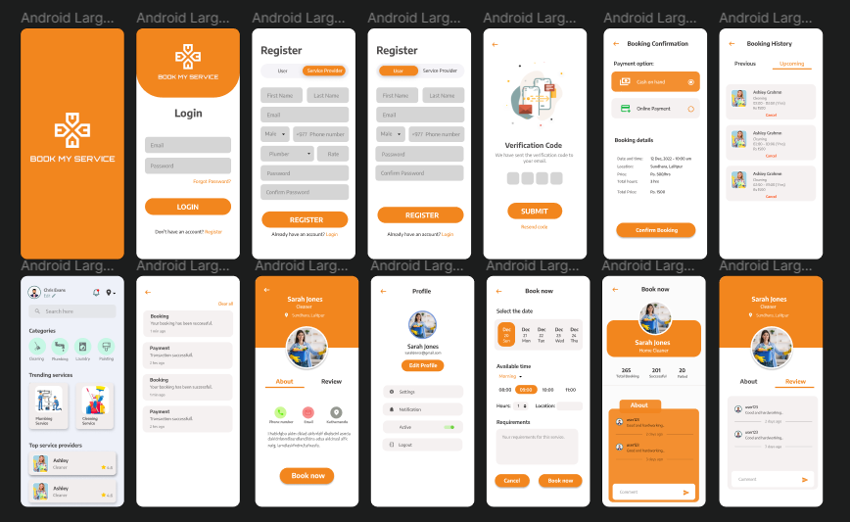

**UI Design of Admin panel:**

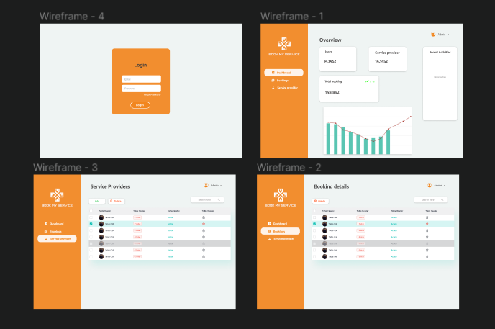

**Reference:**

[**https://dribbble.com/shots/15151451--Home-Service-App**](https://dribbble.com/shots/15151451--Home-Service-App)

[**https://dribbble.com/shots/16909549-Home-Service-App-Project**](https://dribbble.com/shots/16909549-Home-Service-App-Project)

[**https://dribbble.com/shots/15385853-Home-Service-App-I-Ofspace**](https://dribbble.com/shots/15385853-Home-Service-App-I-Ofspace)

[**https://dribbble.com/shots/17874381-On-Demand-Services-App-UI**](https://dribbble.com/shots/17874381-On-Demand-Services-App-UI)